

**UNIVERSITY OF PETROLEUM AND ENERGY STUDIES**

**School of Computer** **Science**

**2020-21**

**GRAPHICS AND ANIMATION TOOLS LAB**

**Faculty: Dr. DURGANSH SHARMA**

**Assistant Professor**

**Department of Cybernetics.**

**School of Computer Science, UPES**

**Submitted By:**

**Name- Vartika Deep**

**Roll no-R100217088**

**Batch-B3**

**Semester- 7**

**Course-B.tech. CSE-OSOS**

**Sap Id- 500062441**

**EXPERIMENT-5**

**Design of 3D Text using Blender**.

**STEPS:**

1.Open Blender delete the existing cube and Click on add and add text.

2.Then make some adjustments in the text like depth and extrude.

3.Add color to the text and add camera point on the boundary of the text.

4.Add the metallic effect and shading to the text and also change the color of the point.

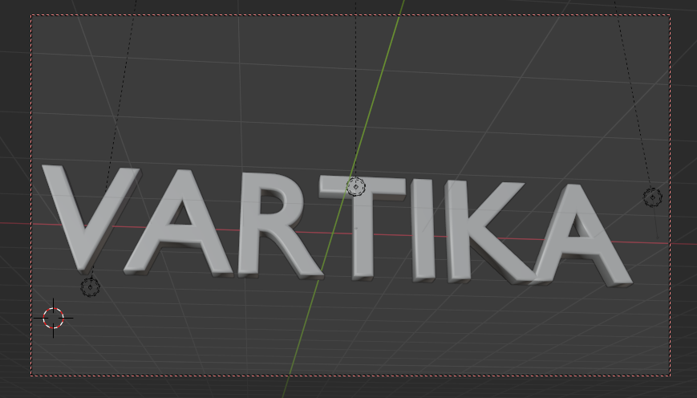

5.Render the animation.

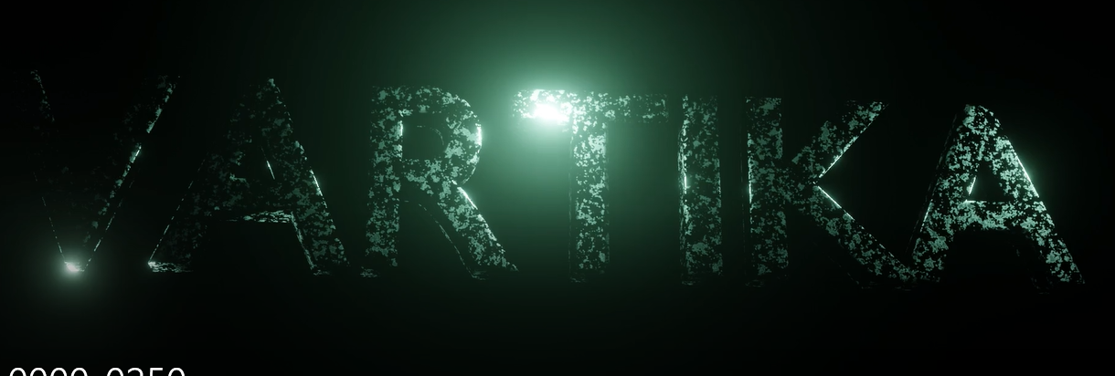

Link: https://drive.google.com/file/d/1j5Z2B42oqv6ZajnSdYDrCidA3Ufz_jb1/view?usp=sharing